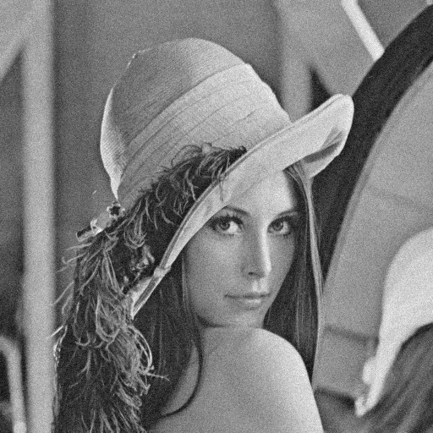

a10 (gaussian_noise 10): 13.599607807300009

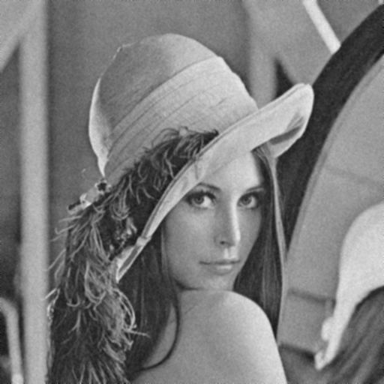

a10_1 (3x3 Box Filter): 17.658119746464237

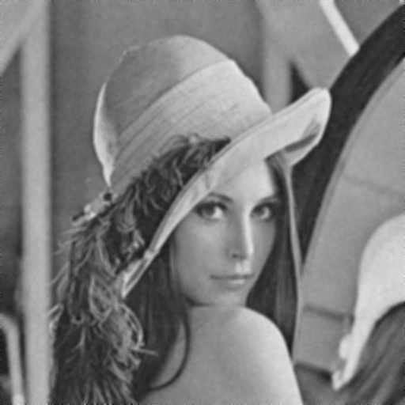

a10_2 (5x5 Box Filter): 14.796591487541546

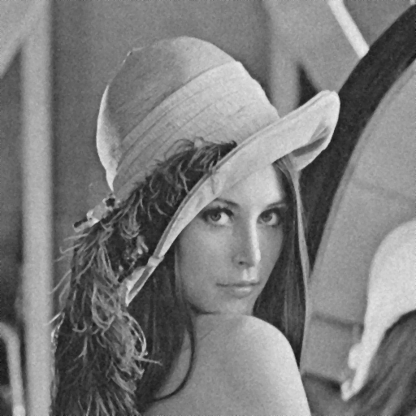

a10_3 (3x3 Median Filter): 17.58395091475316

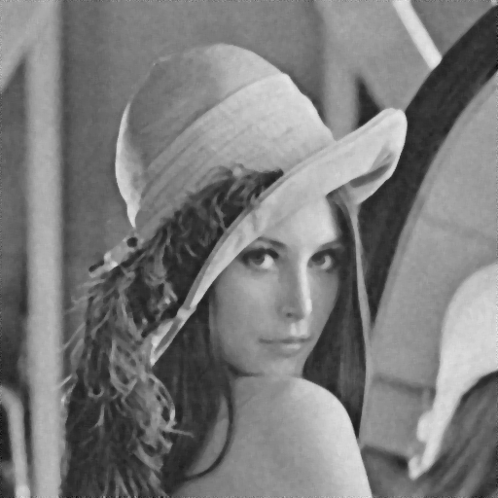

a10_4 (5x5 Median Filter): 15.908868633113869

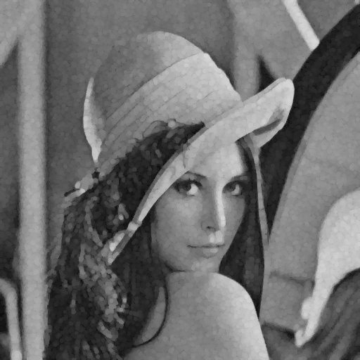

a10_5 (Morphological Opening): 13.690682690993858



a10_6 (Morphological Closing): 14.97542132770879

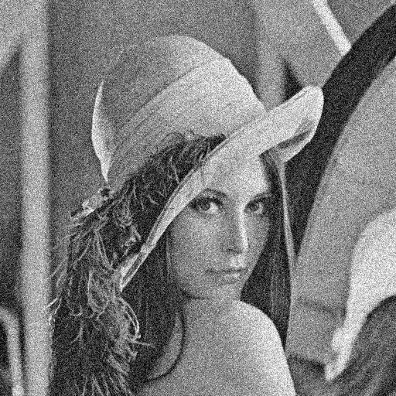

a30 (gaussian_noise 30): 4.175409439774651

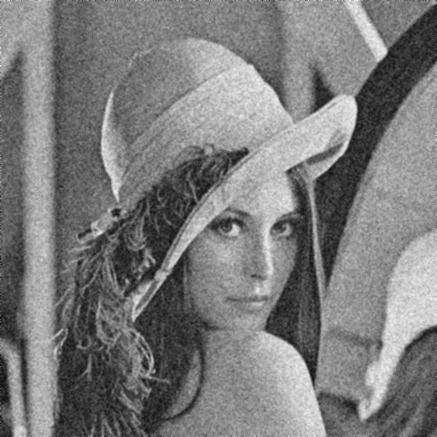

a30_1 (3x3 Box Filter): 12.41382720956453

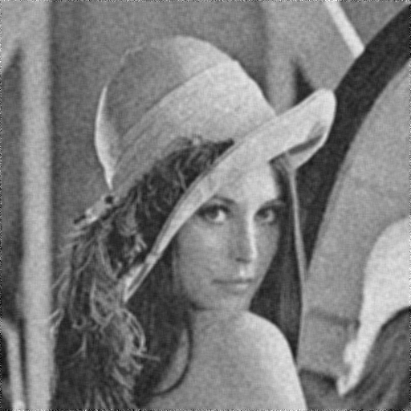

a30_2 (5x5 Box Filter): 12.840224902189696

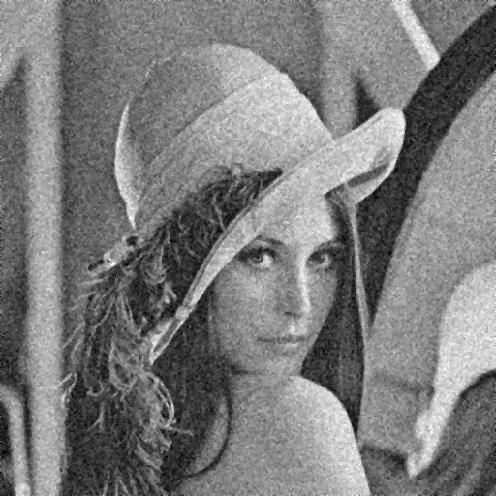

a30_3 (3x3 Median Filter): 10.947424658288522

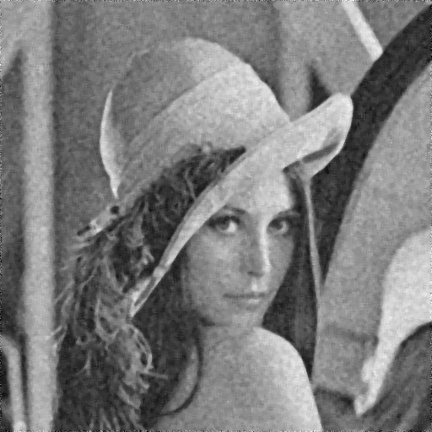

a30_4 (5x5 Median Filter): 12.477912257006551

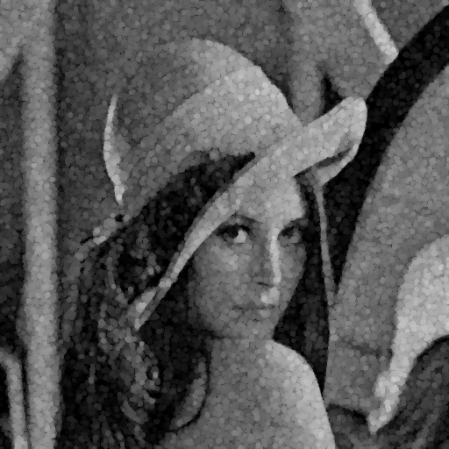

a30_5 (Morphological Opening): 10.343192412496174

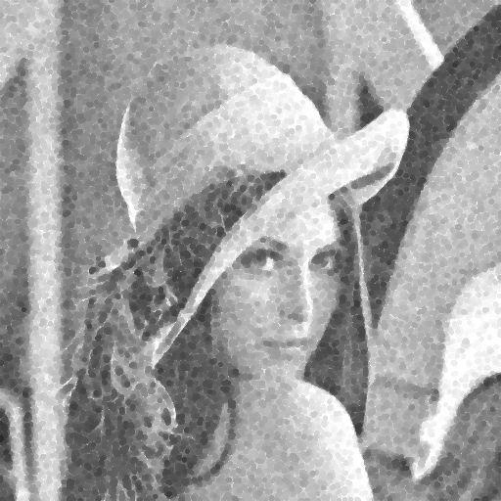

a30_6 (Morphological Closing): 10.566156782440409

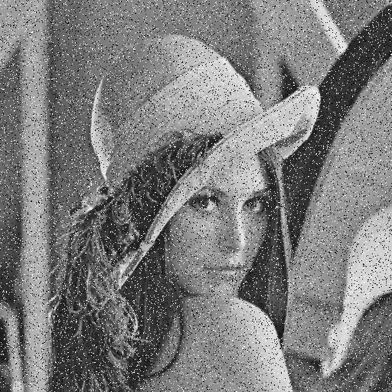

b005 (pepper_and_salt 0.05): 0.8960475845022507

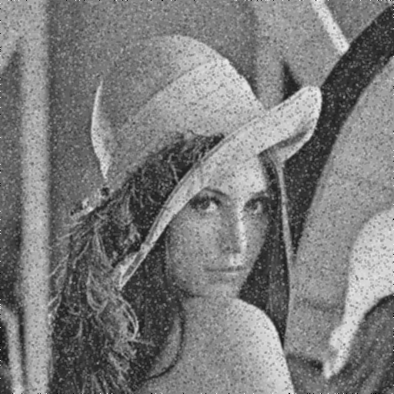

b005_1 (3x3 Box Filter): 9.285375338376397

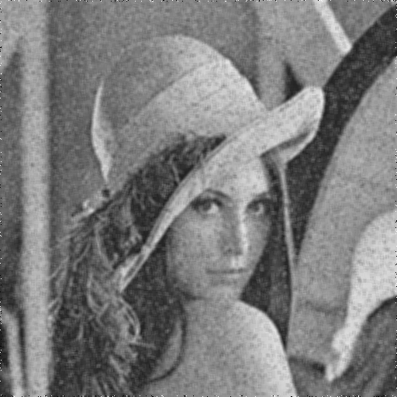

b005_2 (5x5 Box Filter): 10.617402222995093

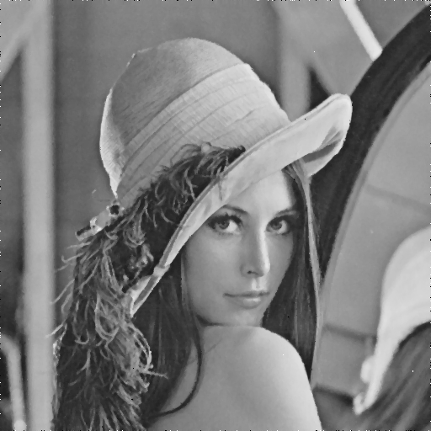

b005_3 (3x3 Median Filter): 17.511552710051834

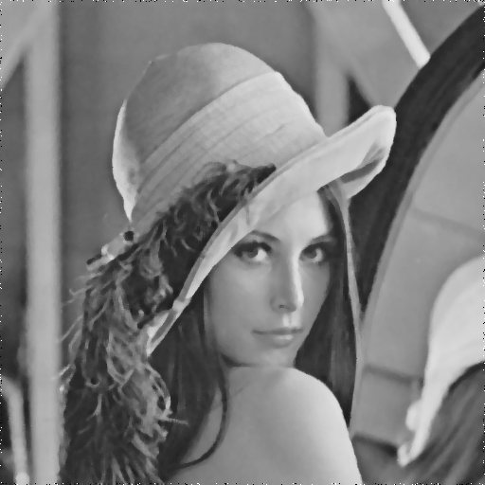

b005_4 (5x5 Median Filter): 14.633861581177502

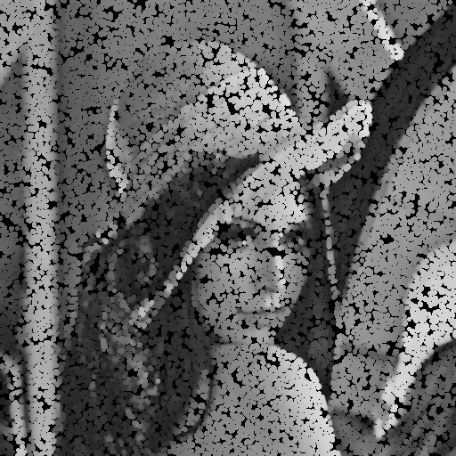

b005_5 (Morphological Opening): 0.17703731339398174

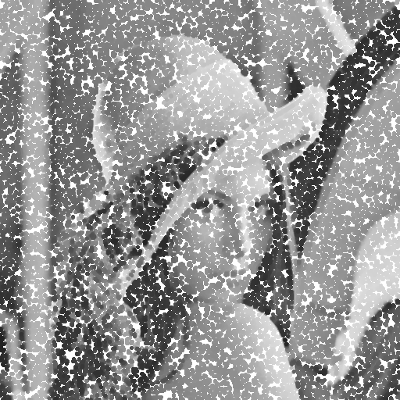

b005_6 (Morphological Closing): -0.06076298430814275

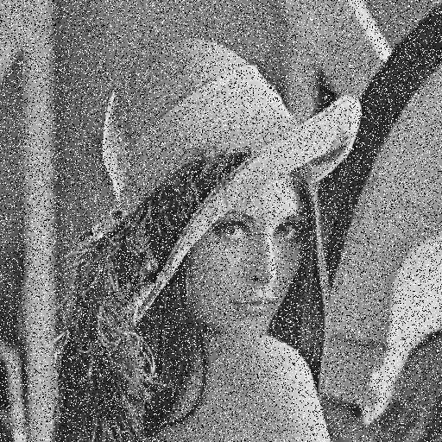

b01 (pepper_and_salt 0.1): -2.097107355917343

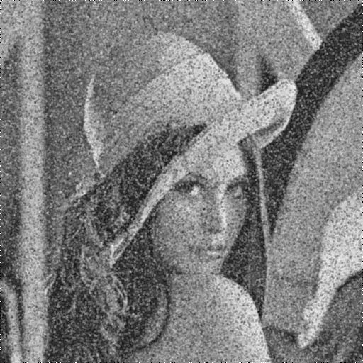

b01_1 (3x3 Box Filter): 6.172854416513415

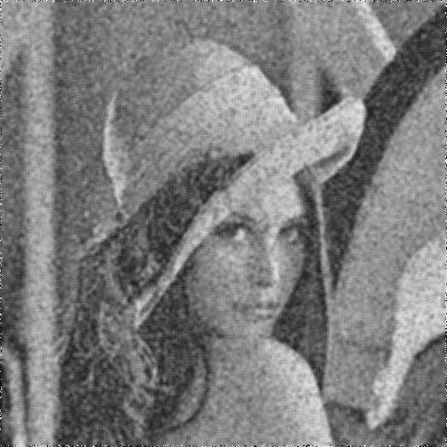

b01_2 (5x5 Box Filter): 7.859545407094043

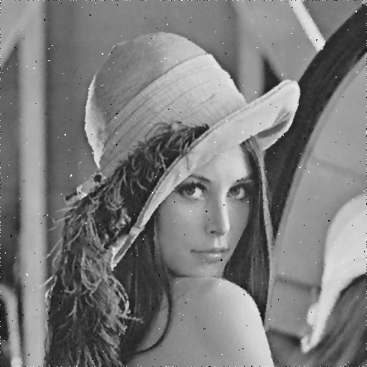

b01_3 (3x3 Median Filter): 13.766479581725058

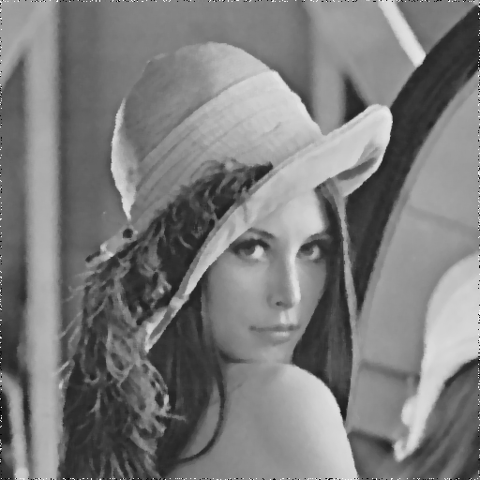

b01_4 (5x5 Median Filter): 12.870879705986937

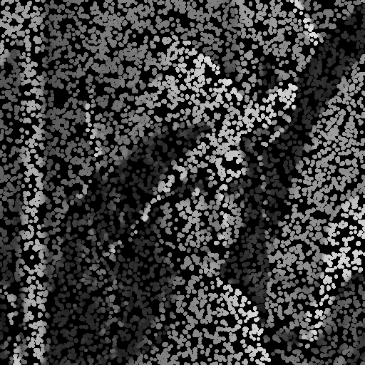

b01_5 (Morphological Opening): -2.8711806479940165



b01_6 (Morphological Closing): -3.2661131461425437